**DAILY ONLINE ACTIVITIES SUMMARY**

|  |  |  |  |  |  |  |  |  |
| --- | --- | --- | --- | --- | --- | --- | --- | --- |
| **Date:** | **14-06-2020** | | | | | **Name:** | **Kavya** | |
| **Sem & Sec** | **6th & A** | | | | | **USN:** | **4al17cs041** | |
| **Online Test Summary** | | | | | | | | |
| **Subject** | |  | | | | | | |
| **Max. Marks** | |  | | **Score** | | |  | |
| **Certification Course Summary** | | | | | | | | |
| **Course** | **C programming 2019:Master the basics** | | | | | | | |
| **Certificate Provider** | | | **Udemy** | | **Duration** | | | **3 Hours** |
| **Coding Challenges** | | | | | | | | |
| Problem Statement:1.  Write a C Program to implement the Binary Reversal  |  |  | | --- | --- | |  |  | | | | | | | | | |
| **Status:Yes I have uploaded the program** | | | | | | | | |
| **Uploaded the report in Github** | | | | | **yes** | | | |
| **If yes Repository name** | | | | | [**https://github.com/kavya-077/DAILY-STATUS**](https://github.com/kavya-077/DAILY-STATUS) | | | |
| **Uploaded the report in slack** | | | | | **yes** | | | |

Online Test Details: (Attach the snapshot and briefly write the report for the same)

Certification Course Details: (Attach the snapshot and briefly write the report for the same)

**C PROGRAMMNG 2019: MASTER THE BASICS**

**What we’ll learn**

* The Basics of C Programming
* Deeply Understand The Fundamentals of Programming
* Solve Beginner Programming Problems
* Get the Knowledge you need to get into Advanced Topics Confidently

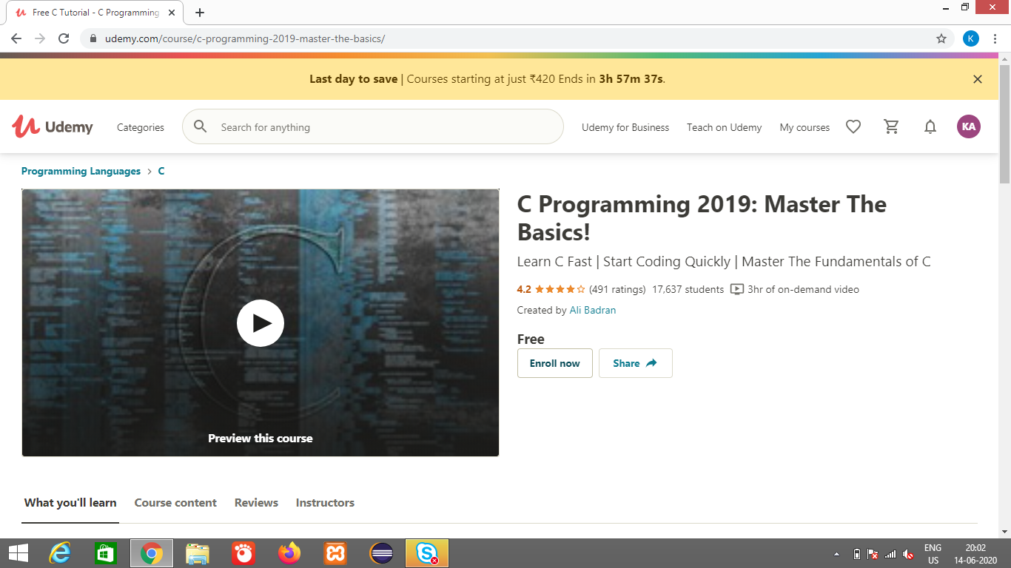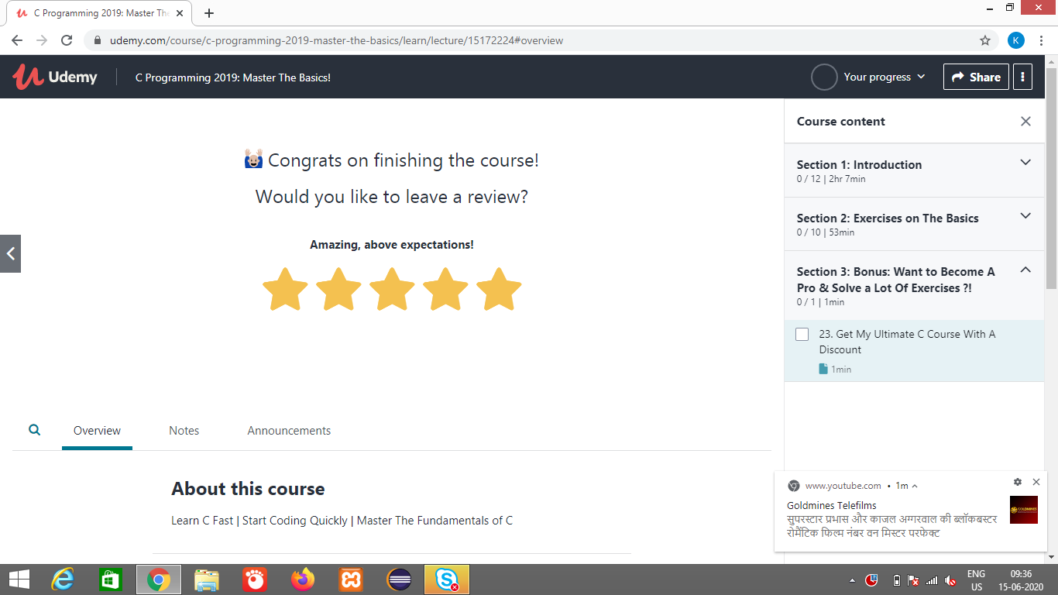

<https://github.com/alvas-education-foundation/kavya-onlinecourse>

Coding Challenges Details: (Attach the snapshot and briefly write the report for the same)

<https://github.com/alvas-education-foundation/kavya-OCA>

<https://github.com/kavya-077/DAILY-STATUS>